Simplified water model for Israel (2023)
Since the water model is only prat of a larger model our goal here was to build a simple model that maps the relations between suppliers and consumers (Figure 1) enables predicting the general trends for water use. The model was developed using data from Israel Bureau of Statistics, the Water Authority and Israel main water providing company (Mekorot, 2021).
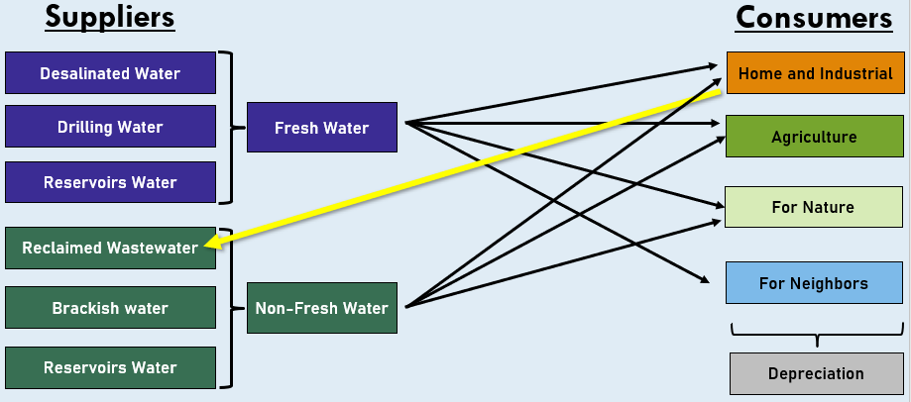
Figure 1: Relation between the water suppliers and the consumers
Model assumptions
• The amount of water provided by the water sources is meeting the demand.
• The amount of water that will be used for agriculture will increase linearly with relation to the population size. Drilling water are spring and aquifers water.
• Due to global warming the amount of natural fresh water will decrease by 25 percent by 2050.
• The relative amount of fresh water used for agriculture out of the total water used will remain the same as in recent years - 35 percent.
• Water supply to the neighboring countries will increase according to the growth of the Palestinian population.
• The amount of wastewater that is reused is 66 percent.
• The influence of external events such as changes in prices, imports or exports and geopolitical events were not considered.
•There is no consideration of economic or physical constraints - for example, the construction of a desalination plant.
• No modeling of the depreciation, the Water Authority's estimates are that the depreciation is about 3 percent of the total consumption (source required).
• The amount of use of brackish water and the sweet and non-sweet reservoir water will not increase over the years.

The model of suppliers and consumers
Our model is based on two components suppliers and consumers where the supplies need to meet the demand of the consumers. Where all the components are a function of the target year (t). See in the following equation where the consumers are on the right side of the equation and the suppliers are on the left side:
$D\left(t\right)+N\left(t\right)+W\left(t\right)+A.W(t)=H\left(t\right)+A\left(t\right)+F.N\left(t\right)+T.N\left(t\right)$ (1)
Where for suppliers D(t)- is desalinated water, N(t) – drilling water W(t) – reclaimed wastewater, A.W(t) – brackish water, fresh and non-fresh reservoir water.
And the consumers are H(t) – domestic and industrial of fresh water, A(t) – agricultural consumption of fresh water only, F.N(t) – water for neighbors (Jordan, Gaza and West bank), T.N(t) – water supplied to nature.
The results of the model according to the assumptions above:
Table 1 - Model results
2050 | 2040 | 2030 | 2023 | Year
1819 | 1504 | 1244 | 1089 | Total | Domestic & Industrial | Consumption
1635 | 1352 | 1118 | 979 | Only Fresh | Domestic & Industrial | Consumption
2070 | 1745 | 1477 | 1321 | Total | Agricultural | Consumption
725 | 611 | 517 | 463 | Only Fresh | Agricultural | Consumption
295 | 250 | 215 | 195 | Water for neighbors |  | Consumption
75 | 50 | 35 | 25 | Water for nature |  | Consumption
4259 | 3548 | 2971 | 2630 | Total |  | Consumption
1819 | 1299 | 847 | 564 | Desalinated water |  | Supply
817 | 903 | 1017 | 1069 | Drilling water |  | Supply
1107 | 898 | 742 | 650 | Reclaimed Wastewater |  | Supply
200 |  |  |  | Fresh reservoir water |  | Supply
200 |  |  |  | Brackish water and non-fresh reservoir water |  | Supply
4177 | 3540 | 3008 | 2683 | Total |  | Supply
16.5 | 13.6 | 11.2 | 9.8 | Population size in millions

Model equations
Population growth
Based on the last 20 years in Israe the model assumes growth of population of 1.92% (central bure of statistics, 2019). But enables changing this assumption.
$$Pop_{j}=Pop_{0}*{\left(1+p_{g}\right)}^{n}$$ | (2)
where $Pop_{j}$ is the total population in year j, n is the difference in years between the baseline year (2017) and the target year, $p_{g}$ is the yearly change in population, and $Pop_{0}$ is the population in 2017 (8.8 million people).

Consumers
Water for domestic consumption
• Domestic water consumption includes industrial consumption, therefore includes benign water and marginal water.
• The average household consumption of fresh water has been stable in the last decade and a half and is about 100 m3, including marginal water is about 110 m3 (Water Authority, 2022).
• The consumption equation :
$$H\left(t\right)=h.p.c*P\left(t\right)$$
  - H – the amount of domestic consumption in million cubic meters
  - t – time, year
  - h.p.c - average household consumption per capita in cubic meters
  - P – population size in millions

Agriculture consumption
The agricultural consumption is calculated according to the size of the population and according to the average consumption per capita for agriculture, which currently stands at about 136 m3 per capita for each year, and it includes about 66 percent of non fresh water and the rest is of fresh water (Water Authority, 2022).
The average agricultural consumption per capita has been decreasing consistently in the last two decades. Based on the data from the water authority the following prediction equation for average consumption per capita (a.p.c) was fitted :
$a.p.c(t)= -10.79*\ln\left(t\right)+168.17 ; t>0$ (3)
with R² = 0.8648
Using eq 3 the total water for agricultural (A(t) is predicated.

$A\left(t\right)=a.p.c*P(t)$ (4)
Water for neighbors
Water for neighbors is measured according to the quantities of water supplied to Jordan and the Palestinians, and it constitutes about 7 percent of Israel's total freshwater consumption.
The supply of water to Jordan is dictated according to periodic agreements that are signed, currently 90 million m³ are supplied (Water Authority, 2022).
The supply of water to the Palestinians is also determined according to agreements, but there are often deviations from the agreements and a higher quantity than the agreement is provided.
In this model we assumed that the amount of water will be related to the population size.

$$F.N\left(t\right)=p.p.c*P.P\left(t\right)+J$$
- F.N – the amount of water for the neighbors in the MLC
• t – time, year
• p.p.c - average Palestinian consumption per capita supplied by Israel
• P.P - Palestinian population size in millions (worldmeter, 2023)
• J - the amount of water supplied to Jordan according to an updated agreement.

Water for nature
These are water that are retuned back into streams for various reasons such as ecology, infrastructure, etc..
These water constitutes on average about 1 percentage of the total consumption and their composition consists of fresh and non fresh water (Water Authority, 2022).
In our model used past data, a schematic forecast from the Mekorot company (Mekorot, 2021).

Table 2 - The amount of water for nature
Water consumption for nature in million cubic meters
2050 | 2040 | 2030 | 2023
75 | 50 | 35 | 25

Suppliers
Desalinated water
Since Israel is relatively dry country, we assumed that the role of desalinated water is to bridge the gap between demand and supply. Therefore, this is how the required amounts of desalination are calculated (Water Authority, 2022).
Thus, we rearranged the equation 1 for forecasting the amount of desalinated water required:
$$D\left(t\right)=H\left(t\right)+A\left(t\right)+F.N\left(t\right)+T.N\left(t\right)-N\left(t\right)-R.W$$
Where for suppliers D(t)- is Desalinated water, N(t) – natural water (surface water reservoirs, spring water and drilling), R.W(t) - fresh water reservoirs.
And the consumers are H(t) – domestic and industrial of fresh water, A(t) – agricultural consumption of fresh water only, F.N(t) – water for neighbors (Jordan and Gaza and West bank), T.N(t) – water supplied to nature.

Water form nature
Due to the climate change the supply of natural water is expected to decrease in the future due to a consistent decrease in the amount of precipitation, which makes it difficult to fill the water reservoir from which they draw (Water Authority, 2022).
According to a forecast by the Mekorot company, by 2050 there will be a 5 percent decrease in the amount of precipitation, and this will reduce the volume of refilling in the reservoirs (Aquifers, lakes etc.) between 20 and 30 percent (Mekorot, 2021).
Therefore, in our model we calculate a decrease in natural water supply linearly with target of reduction in 25 percent use of natural water in 2050.

Reclaimed Wastewater

The percentage of the amount of wastewater that are reuse is relatively consistent in recent years it about 66 percent of the water supplied to the homes and industry. While this might change in the future due to technological improvements. In our model we use 66 percent in the calculations. It should be noted that currently this water is used for mostly agriculture therefore in this scenario that was test we assume that the there will be increase in use for water for agricultural proportional to the population growth.

Brackish water, fresh and non-fresh reservoir water
• The brackish water is a supplementary water source for the various requirements, where it mainly supports agricultural consumption, but about 20 percent of it is also allocated for domestic consumption. In recent years, the use of brackish water averages 220 ml3 per year.
• Reservoir water that is not fresh is used for a variety of uses such as water for agriculture, nature and more. This amount of water varies according to the amount of annual precipitation and therefore cannot be predicted. Here, too, in recent years, the use has averaged 30 million cubic meters per year.
• Water from fresh reservoirs that are above the ground (including lakes) and are used as drinking water and stand for a relatively constant amount of 150 milliliters per year.
• For brackish water, there is no planning to increase the pumping and it is relatively constant, therefore we chose to take the brackish water, fresh and non-fresh reservoir water as a fixed figure and it is 400 million cubic meters per year (Mekorot, 2021).

Resources
- Water consumption in Israel 2021 - (Water Authority), 2022)
- Production and consumption of water - (Central Bureau of Statistics,2022)
- The Israeli population forecast - (Central Bureau of Statistics, 2019)
- Palestinian population growth forecast (worldometers, 2023)
- The water forecast in Israel - (Mekorot, 2021)

